Loch Lomond Angling Association
Pike Fly Fishing Competition
Sponsored by Glasgow Angling Centre
Prizes
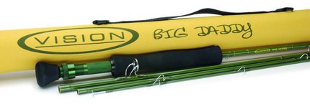

GU2423 Big Daddy #9 Rod + Cap
Vision's Big Daddy rods are great choice for casting big, air resistant flies for pike and other predators.
The powerful medium fast action is forgiving and pleasant when casting, but has brutal power for fighting monster size pike, and being a four piece blank, the Big Daddy is easy to pack when you're traveling.
Finished with the high quality, durable fittings you expect from Vision, and in a distinctive colour that let's others on the bank know you mean business!
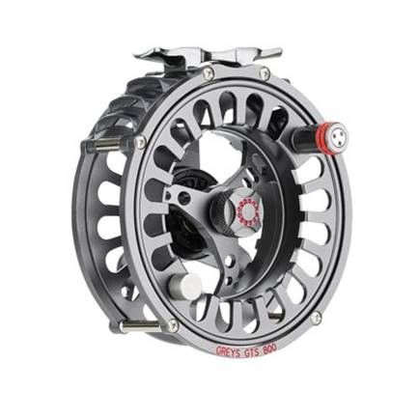
GR2368 GTS800 9/10 Reel + Cap
The Greys GTS800 balances perfectly with most good quality fly rods and reduces stress on the casting arm. It is capable of withstanding the rigors of modern-day fly fishing and features vented side plates to reinforce the reel even further. The venting also gives the reel its distinguishable character and unique appearance so you can arrive at your fishing venue with a reel that exudes class and quality.
Of course, having a light, durable, and pretty looking reel is fantastic, but it still needs to stop fish. So the GTS800 is fitted with a Rulon disc drag system. Rulon is a hard-wearing, extremely high performing plastic which is excellent at dissipating heat. And because it can withstand high temperatures through friction, it doesn't degrade when the drag is engaged in some severe breaking. Think of the disc drag on a fly reel like the rubber breaks on a bicycle. To stop the bike, you apply pressure on the brake handle which engages the rubber break with the wheel. However because rubber doesn't withstand high temperatures, it wears down significantly. Rulon, in contrast, it far more efficient, so you can be confident that your fly reel discs are not going to wear down prematurely or otherwise warp from the constant friction and strain of fly fishing and fighting fish.
Most modern fly reels are now large arbor, and the GTS 800 falls into that category, for many good reasons. A large arbor reel can hold a generous amount of backing, so when you do engage with a hard fighting fish that decides to take long runs, you can be confident that you have plenty of backing to run into when the fish decides to take the whole line out. Large arbor also increases your retrieval rate per single turn, so you can reel your fly line in quicker when you need to move to a different spot, or indeed, land a fish. The reel also benefits from a quick release spool that is simple to operate and lets you swap fly lines in no time. For example, you may be fishing with a sink tip fly line one minute; a floater the next, therefore you need a quick system that lets you respond to the changing conditions and fly fishing circumstances. And when you are not using the reel, it comes with a handy neoprene pouch for protection.

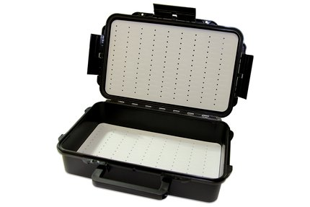

FM0771 Xtreme Med Box + Clydesdale fly set + Cap
Fulling Mill Fly Box,These high quality Italian Manufactured Fly Boxes are IP67 Rated – Dust Proof and Water Proof to 1m.
With strong clips and a carry handle on the largest model this flybox is sturdy, handsome and ergonomic, store and transport your flies in style.
Together with a large selection of Pike Flies that will attract the biggest of predators!!

